Galveston Bay Watershed Trash Action Plan:

A regional partnership plan for addressing litter and marine debris

Draft April 2019
Litter in the Galveston Bay watershed flows into waterways and eventually becomes marine debris in Galveston Bay. The watershed includes half of the state population and extends from the Gulf of Mexico to the Dallas-Fort Worth metroplex. State agencies and non-profits have responded to the litter issue by independently organizing clean-ups, outreach and education programs, and data collection strategies. According to a 2017 study by Texans for Clean Water, litter cleanup initiatives in the city of Houston alone cost an estimated $13.3 million annually.
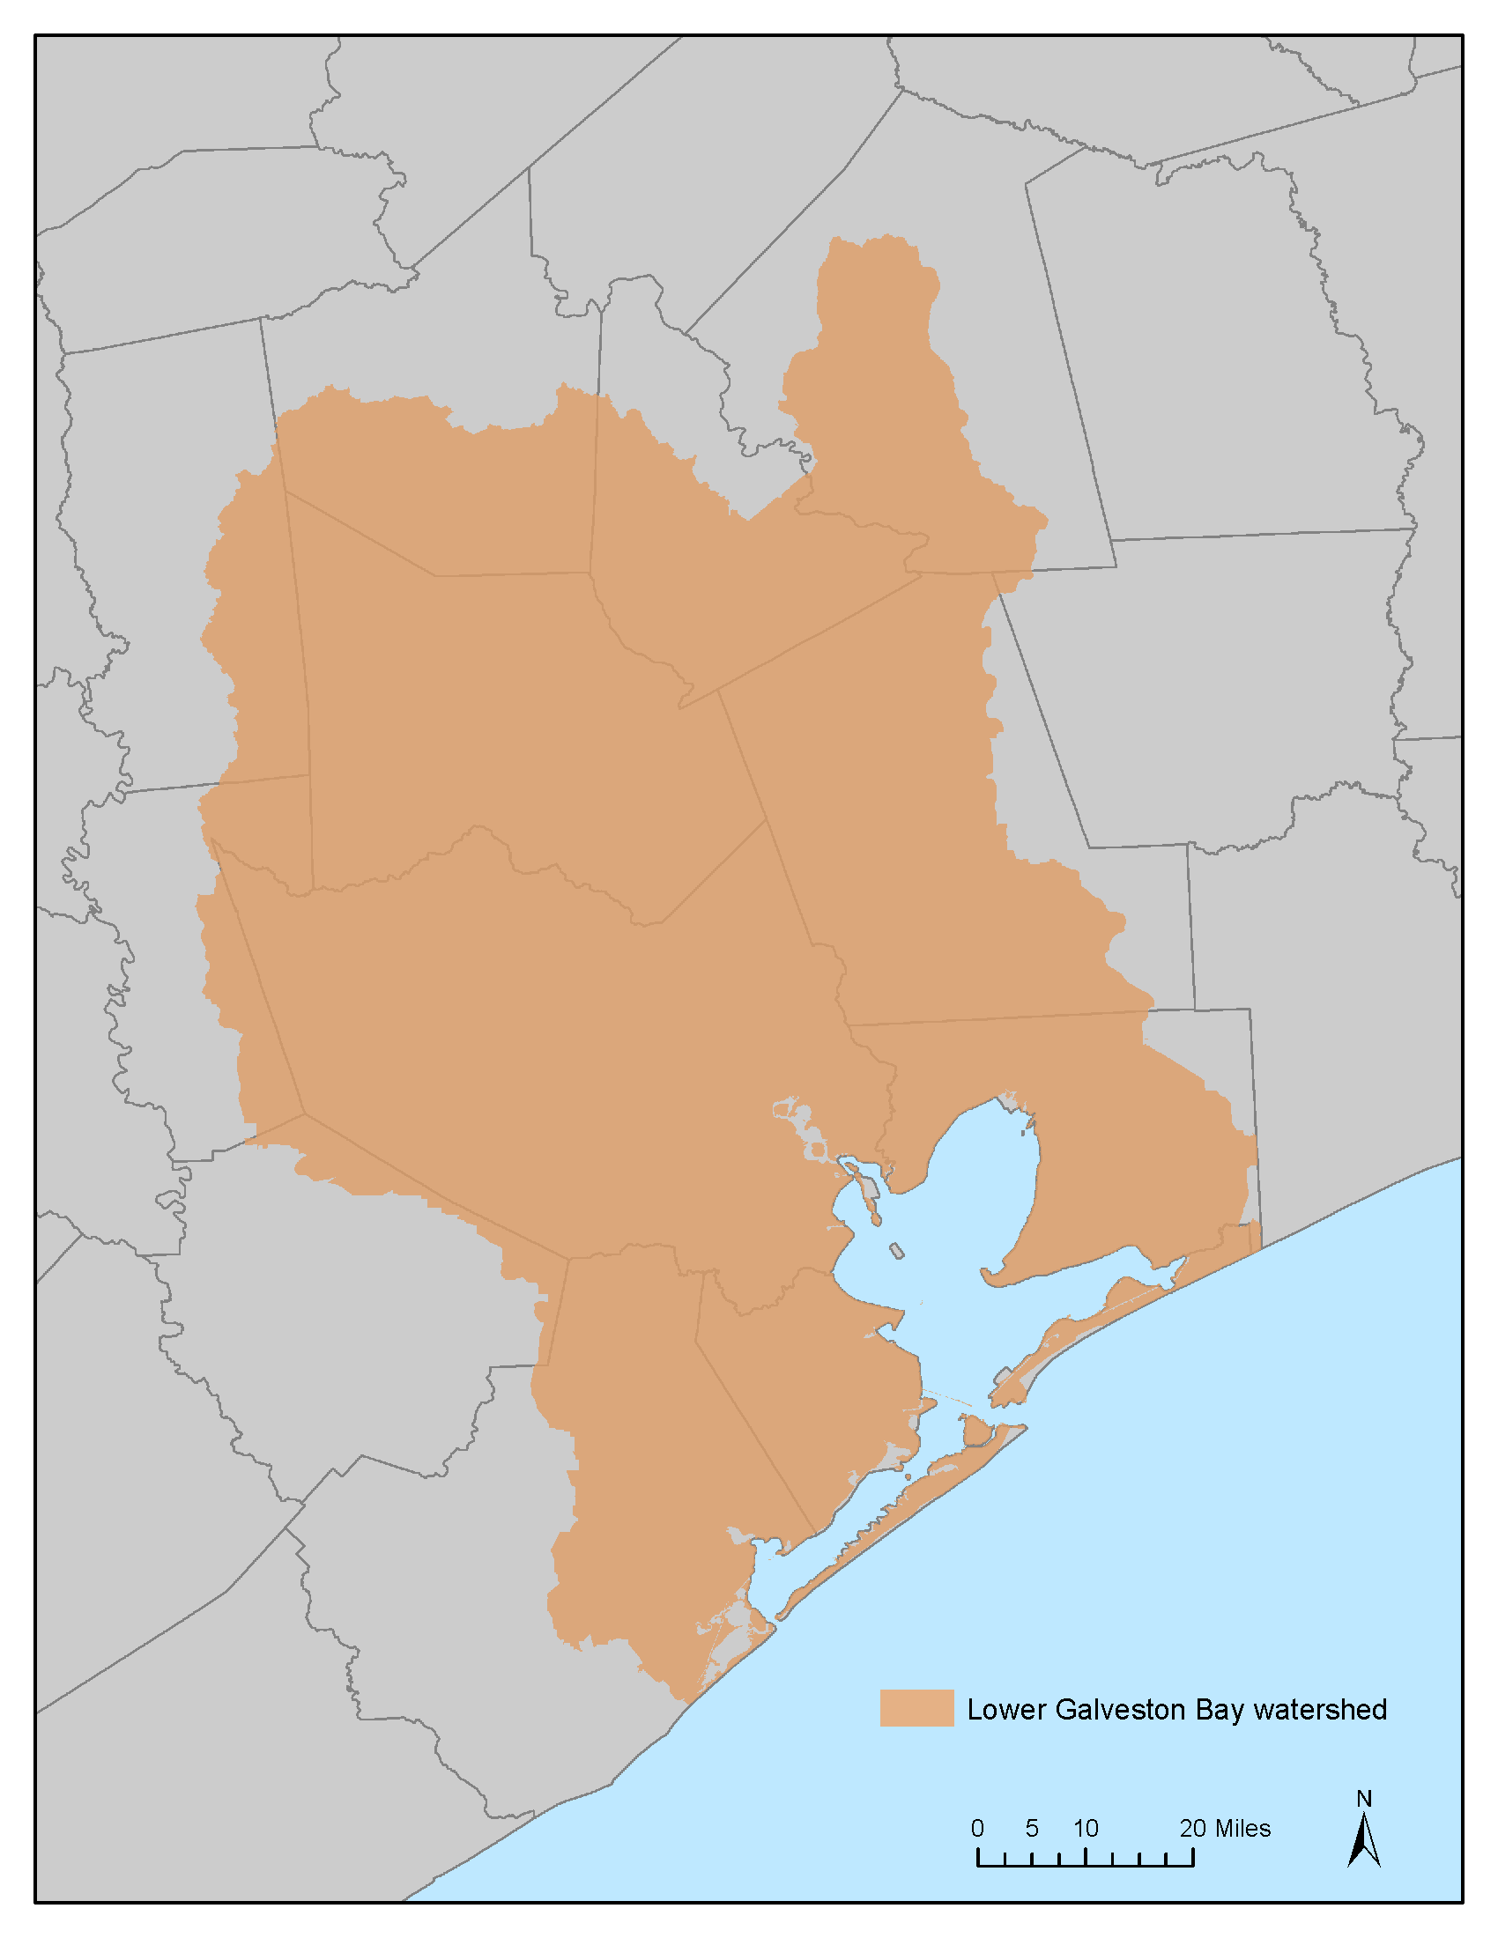
Figure 1. Lower Galveston Bay watershed in the Houston-Galveston Region.
Government agencies and departments and non-profits recognized that their work would benefit from increased collaboration and a region-wide plan to identify sources and types of trash, coordinate removal efforts, and create prevention strategies.
In April 2017, stakeholders* in the Houston-Galveston region (Figure 1) concerned about trash and debris in the bayous, on the beaches and in Galveston Bay came together to address the problem of marine debris in the region’s bayous and beaches, and in Galveston Bay. At the first Trash Summit meeting, the stakeholders considered marine debris a serious threat to human health and safety, wildlife, aquatic habitats, commerce, and tourism. The goal of this first meeting was to determine priorities and best-practices that would help frame The Greater Houston-Galveston Trash Plan. Similar marine debris plans from across the country (Hawaii, Florida, Oregon, Great Lakes) were consulted for examples of structure, methodology, and estimated timelines. Following a second Trash Summit, and a series of conference calls, stakeholders developed an outline of this plan.

Outline in hand, stakeholders reviewed their common goals and practices and examined existing programs and efforts in the Galveston Bay watershed, including projects in Fort Worth and Dallas. They also identified potential strategies and evaluated possible solutions that would prevent and reduce marine debris in the Houston-Galveston region.
Stakeholders tied this analysis to three major goals for the initial draft Galveston Bay Watershed Trash Action Plan. Each goal includes several strategies and underlying tasks, including examples of current efforts in the Galveston Bay watershed. The structure of the Trash Plan is designed to be open-ended and inclusive so that it can be adapted to future successes and new challenges.
The purpose of the Trash Plan is to serve as a guidance document or a central point of reference for improved collaboration and coordination among the multitude of stakeholders across the Greater Houston-Galveston region, and to avoid duplication while enhancing the strength and efficiency of their efforts. The Trash Plan is not intended to be regulatory or specifically binding on actions or timeframes.

Goal 1: Conduct High Quality Research and Needs Assessment
It is imperative to be able to know the types and amounts of litter and trash and the hotspots in the region for litter and trash accumulation to be able to target prevention, outreach, education, removal and research efforts. While several entities are documenting cleanup efforts throughout the area, the Houston-Galveston region does not currently have an ongoing effort to document trash and litter through a regional database. The last regional study that conducted field work to assess the problem was conducted in 1993 (Morgan and Lee, 1993). The recently published Galveston Bay Report Card determined that litter and trash are a major concern of the Houston-Galveston region’s residents and visitors, but little had been done to define and understand the growing trash and litter problem in bayous throughout the Houston-Galveston region. New and accurate data are essential to address the underlying causes of this serious problem, which injures and kills wildlife, interferes with navigation safety, and poses a threat to human health. Research data will be critical in developing a cost-effective and efficient regional action plan. It is necessary to answer the question of how best to assess the type, quantity, and source of trash and litter in the region’s most problematic and polluted bayous. Stakeholders identified six strategies, outlined below, to aid in answering that question.

Strategy 1.1 Identify Resources, Current Efforts and Costs of Current Efforts

Task 1.1.1 Create a digital resource that identifies current efforts and assets of each organization involved in present and future work to prevent and remove marine debris. This resource file will include their efforts (e.g. cleanups, education events and campaigns, etc.) to address the problem. Listed are examples of current efforts that could be included:

- Data mine MS4 permits and Stormwater Management Plans of regional municipalities for their floatables outreach and management plans.
- Trash Free Texas Adopt-a-Spot Program.
- Trash Bash and other cleanup activities keep documentation, either qualitative or quantitative.
- GBF use of the Ocean Conservancy’s Clean Swell trash collection app during shoreline clean-up efforts.
- TrashFree Waters implementation of two products:
  - Atlas on municipal and state activities related to debris management – programs and policies that have been shown to reduce debris.
  - Great Practices – the current best practices available
- Texans for Clean Water’s report “The Coast of Litter & Illegal Dumping in Texas” that includes costs spent by 9 cities across Texas.
- Endeavor to capture public and private sector costs, as well as costs for different types of efforts, such as clean-up, outreach.
- EPA Trash Free Waters…

Task 1.1.2 Convene researchers to foster partnerships and collaboration and expand knowledge base. Researchers to be convened annually.

Strategy 1.2 Data Gap Assessment to Prioritize Needs

Task 1.2.1 Perform data characterization to frame and understand current data sets, including metadata availability (quantity and quality of data, dates available, geographic regions available)

Task 1.2.2 Create forum for governments, non-profits, NGOs and researchers to analyze data gaps, improve collaboration, and share data.

Task 1.2.3 Establish baseline datasets that will comprise the following:
- estimated quantity of regional marine debris;
- composition of regional trash and plastic pollution;
- hotspots of waterway trash;
- costs of removing trash and plastic pollution;
- cost-based trash and plastic pollution recycling and re-use options;
- costs associated with trash and plastic pollution impacts;
- estimated volumes/types of trash and plastic pollution removed annually;
- education/communications resources; and
- locations/quantity of abandoned and derelict vessels.

Strategy 1.3 Develop understanding of life cycle, transport, quantity and accumulation rate of marine debris

Task 1.3.1 Identify research priorities for life cycle assessments of land-based and water-based debris. Establish priorities for research to improve knowledge about ecological and economic impacts of marine debris.
- Perform gap assessments and evaluate lessons learned from research priorities. Examples include:
  - Identify and develop database for information on entanglement/ingestion, and habitat;
  - How to increase access to and share data;
  - Identify hotspots for marine debris interactions and impacts;
  - Identify/develop a regional model and/or trend analysis to inform managers;
  - Review research on wildlife interactions with, and impacts of, marine debris that include microplastics cycling and uptake by wildlife, hotspots of interactions, health and risk assessment, long term and cumulative effects.

Task 1.3.3 Evaluate effectiveness of Best Management Practices for mitigation and removal.

Task 1.3.4 Identify emergency response protocols and identify/develop regional strategies to mitigate debris impacts on wildlife habitats.

Strategy 1.4 Monitoring

Task 1.4.1 Identify organizations that use water debris containment systems and determine whether they quantify types of debris that are collected. Analyze existing data and emphasize ongoing quantification.

Task 1.4.2 Compile data from selected cleanup organizations. Determine whether monitoring is part of their initial clean-up activities and is ongoing.
- Compare cleanup sites to debris accumulation sites to evaluate and monitor impact of cleanup sites.

Task 1.4.3 Using data gaps assessment (Strategy 1.3) and results, from Tasks 1.4.1 – 1.4.X, develop monitoring priorities.
- Short-term and long-term
- Identify possible funding sources
- Use forum from Task 1.2.2 to communicate priorities and get updates on status of priorities

Strategy 1.5 Establish Standardization (Metrics and Metadata)

Task 1.5.1 Review programs that implement data collection methodologies such as NOAA Marine Debris Program, Ocean Conservancy, EPA Trash Free Waters Debris Collection Data Protocols and Texas Clean Rivers Program to create an effective and proven methodology for region.

Task 1.5.2 Develop new a data management collection system, or adapt a successful one, using relevant facts and details from Houston-Galveston region, and then establish a communication strategy that promotes information inputs from other regional organizations.

Task 1.5.3 Identify metadata on land-based and water-based debris that are aligned to following elements: a) Open & Nearshore Water b) Shoreline c) Deep & Nearshore Sediments d) Fisheries e) Water Infrastructure (wastewater systems, stormwater).

Task 1.5.4 Using same established methodologies for review from Task 1.5.1, develop metadata criteria, from optimal to minimal requirements.

Strategy 1.6 Research Effectiveness of Communications Campaigns

Task 1.6.1 Develop and monitor communications metrics to assess effectiveness.

Task 1.6.2 Develop strategies to determine effectiveness of outreach campaigns.

Goal 2: Reduce Land-Based and Water-Based Debris through Prevention
The lower Galveston Bay watershed is home to a diverse population of more than 10 million people. The watershed’s residents produce about 11.3 million pounds of plastic per day, nearly 3 billion pounds per year.
According to a 2009 study on littering, about 85% of littering is the result of individual attitudes (KAB, 2009). Changing individual behavior is key to preventing litter. Most littering behavior (81%) occurred with notable intent. This included dropping (54%), flick/fling of the item (20%), and other littering with notable intent (7%). The actual count of overall litter is down 61 percent since 1969, a result of successful education, ongoing cleanup efforts and changes in packaging, and is reflected in dramatic reductions of paper, metal and glass litter. However, plastic litter has increased by 165 percent since 1969 (KAB, 2009). Continuing population growth will continue to put pressure on litter abatement efforts. Even if litter is reduced on a per capita basis, more people will still tend to result in more litter.
As urbanization and population growth increases, local stakeholders and communities must develop novel and collaborative strategies to reduce litter. Galveston Bay watershed stakeholders must ensure that messaging is as unique and diverse as the communities themselves. Identifying the sources of trash is complex. Strategies that can deployed in a multi-level approach will create unique partnerships to help disseminate the litter abatement message. Tapping into the resources, talents, and stewardship of diverse groups, from education and the arts to merchants and businesses, will empower area residents and visitors to take pride in a clean Galveston Bay for generations to come.

Table 1: Main sources of marine debris worldwide. (Taken from the Florida Marine Debris Reduction Guidance Plan, January 2017)
Main land-based sources of marine debris | Main water-based sources of marine debris
- Urban debris in runoff (from city streets, public parks, waterfronts and other land surfaces of coastal areas or farther inland);  - Municipal landfills;  - Ports and marinas;  - Airborne sources. | - Commercial boats;  - Cargo and cruise ships;  - Recreational boats;  - Aquaculture facilities;  - Offshore petroleum and gas platforms.

Strategy 2.1 Increase Awareness and Change Behavior

Task 2.1.1 Identify education/communications resources that are currently available and identify gaps on content and style/type.

Task 2.1.2 Create new or adapt existing educational/communications resources that target specific segments in the region focused on specific behaviors to foster sustainable behavior changes.

Task 2.1.3 Work with regional partners to conduct “train the trainer” webinars and workshops to implement sustainable behavior changes throughout the watershed.

Task 2.1. Engage tourism industry marketing organizations and their agencies to help develop creative marketing/communications strategies for businesses to encourage behaviors that support sound sustainability practices.

Task 2.1.5 Partner and collaborate with visual and performing arts organizations to communicate the impacts of trash, plastic pollution and marine debris and to highlight projects and exhibits focused on reusing, reducing and recycling and eliminating trash and plastic pollution.

Task 2.1.6 Engage schools and school districts to incorporate trash and plastic pollution lesson plans into classrooms.

Task 2.1.7 Increase capacity for regional boater waste programs.

Task 2.1. 8 Disseminate information to boaters through outreach events (e.g. boat shows, fishing tournaments and local events.)

Task 2.1.9 Increase partnerships with marina managers encouraging them to develop programs and outreach efforts within their own facilities. Conduct workshops and webinars for marina managers and marina staff on best management practices.

Task 2.1.10 Work with local governments to identify communication gaps and developing resources and materials.

Task 2.1.11 Promote existing vessel turn-in programs (GLO, TPWD, Counties) and identify needs/gaps and causes of abandoning vessels.

Strategy 2.2 Promote and Encourage Producer and Merchant Responsibility

Task 2.2.1 Develop a plan and encourage regional food service leadership organizations to increase use of sustainability and conservation practices, suppliers and products.
Task 2.2.2 Create programs/opportunities addressing the reduction of single-use plastic items.
Task 2.2.3 Work with regional partners to conduct “train the trainer” webinars and workshops to implement sustainable behavior changes throughout the watershed.
Task 2.2.4 Engage advocacy groups and decision makers in trash and plastic pollution public policy education.
Task 2.2.5 Foster creative problem solving for reducing trash and plastic pollution sources and/or removing existing litter by identifying cost-based recycling, re-use, and removal options.
Task 2.2.6 Target policies/strategies to address source issues.
- Engage local industries, manufacturers and merchants to increase corporate responsibility for the end of life of products.
- Work with manufactures to reduce volume of plastic packaging.

Strategy 2.3 Enhance Efforts to Support Waste Reduction

Task 2.3.1 Compile and disseminate information to local governments and organizations to foster use of best practices at special events.
- Collect and disseminate information on best practices for event planning/managing for outdoor public events to improve debris disposal, recycling, and reduce single-use plastics.
- Collect and disseminate information (plans, documents, articles) on best practices for bin management, signage, and communication.
- Identify ways to reduce balloons, balloon strings, beads, fireworks debris, and other celebratory items.
Task 2.3.2 Organize expert workgroups to collect information, review and prioritize needs/opportunities that reduce water-based debris for beaches, rivers, waterfront parks, bridges and piers.
Task 2.3.3 Maintain online resources including a website (donttrashagoodthing.org), and other online tools that share existing resources. Develop new documents including tip sheets, PowerPoint presentations, guidance plans etc., and make them available online.
Task 2.3.4 Support knowledge sharing between local, regional, and state organizations.
- Develop a plan to facilitate/encourage region and state-wide collaboration and knowledge-sharing activities which connect civic organizations, municipal organizations, and nonprofits/environmental organizations.
- Disseminate available resources for outreach and volunteer training, adoption programs, tools for cleanup efforts, and education materials.
- Disseminate effective communication strategies and research data to neighborhood associations, local businesses, and advocacy groups.
Task 2.3.5 Increase incentives for reducing single-use plastics and plastic bags and increase incentives for water refill stations and reusable bags.

Goal 3: Support and Sustain Removal of Debris, Trash and Debris
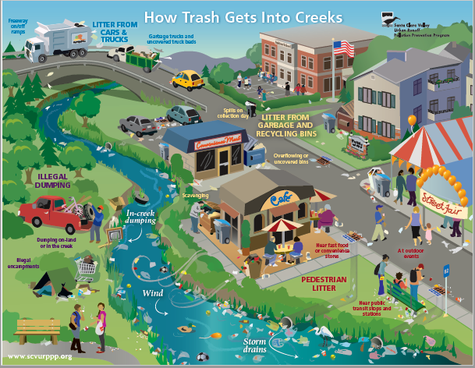
Figure 2. How Trash Gets In Creeks. https://www.epa.gov/trash-free-waters/clean-water-act-and-trash-free-waters#cwa-tools

Research to quantify the sources and types of debris and strategies to reduce sources of land- and water-based debris through prevention may ultimately result in cleaner waterways. In the interim, strategies to support and sustain removal of debris, trash, and debris are essential. As illustrated in Figure 2, escaped trash ends up in the water, and someone must get it out to protect the health and safety of human and aquatic life. Debris cleanup, through single-day events and long-term programs, help by cleaning specific areas, especially those with ongoing issues. Physical containers and technology to collect debris, and a plan to dispose of the trash, can reduce the quantities that end up on the ground and in the water. Identifying and organizing partners to respond is vital to support and sustain removal of large-scale debris, including when disaster strikes.

Debris for removal in this plan includes three categories. The first category includes trash, litter and illegal dumping. Debris removal strategies for this category include identifying hot spots, promoting and supporting cleanups, and utilizing appropriate physical mechanisms to prevent accumulation of debris.

Disaster debris is the second category. Unexpected catastrophes result in potentially large and hazardous amounts of debris, so preplanning for removal strategies is crucial and requires a high level of structure and organization.

The final category is large debris, and in this region commonly refers to abandoned and derelict vessels and submerged automobiles. This type of debris requires specialized procedures and resources.

Despite the type of debris to be removed and the location of the removal, having a plan and building partnerships will go a long way to achieving removal goals.

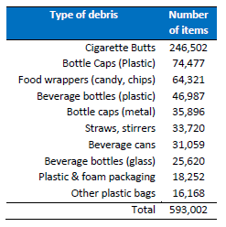
The top 10 most common marine debris items collected in Florida during the 2015 International Coastal Cleanup event (total items collected: 952,568).
MAIN TYPES OF DEBRIS AND TRASH IN FLORIDA, by item and by category, based on Florida statistics. (From the Florida Marine Debris Reduction Guidance Plan, Jan. 2017)
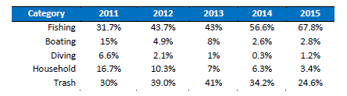
Relative prevalence (percent %) of marine debris recovered during the Southeast Florida Reef Cleanup events between the years 2011 and 2015.

Strategy 3.1 Removal of Traditional Debris

Task 3.1.1. Promote and Support Cleanups
- Advertise, endorse and volunteer for efforts like: Bays 'N Bayous Trash Bash, GLO Adopt-a-Beach, regional Keep Texas Beautiful and adopt-a-spots, etc.

Task 3.1.2. Identify Debris Hot Spots
- Work with local governments and other groups (KTB affiliates, etc.) to identify debris hot spots.
- Identify, develop, or adapt best management practices to target specific environments or debris types and share with stakeholders.
- Promote the use of online tools like Galveston Bay Action Network online tool and smartphone app for reporting pollution and www.trashfreetexas.org.
- Engage residents, especially youth, in service learning projects to prevent and remove debris and trash.

Task 3.1.3. Enhance Efforts to Utilize Physical Mechanisms to Prevent Debris
- Support the use of appropriate trash capture technologies that can be deployed at different locations, when and where practicable, including:
  - Storm drain inlets, the entry points to the stormwater system,
  - In-line, within the pipes or at outlet of stormwater systems, and
  - Open-water, such as a floating boom or trash vacuum boat, in the receiving water body (Source: https://www.epa.gov/trash-free-waters/clean-water-act-and-trash-free-waters#cwa-tools).
- Identify funding sources for the placement AND regular maintenance of trash/recycling containers in public and private spaces; including parks, recreational facilities, boat ramps, marinas, public beaches, retail/commercial shopping centers, etc.
- Support installation of target trash receptacles (for example: cigarette butt canisters, fishing line receptacles, trash cans with messaging)

Strategy 3.2 Removal of Disaster Debris

Task 3.2.1 Provide year-round education about separation of storm debris into correct piles to facilitate removal and proper disposal by type of item.

Task 3.2.2 Encourage local government attendance debris management workshops.

Task 3.2.4 Identify existing disaster debris notification, response, deployment, and reporting systems.

Task 3.2.5 Provide resources to coordinate with government/industry agencies for rapid response to debris from a catastrophic manmade or natural event. The goal of this group should be to focus on the impact of the debris on humans, wildlife, and habitat and assist with removal that protects those interests.

Strategy 3.3 Increase Capacity for Large Debris Removal

Task 3.3.1 Support efforts to remove abandoned vehicles from the region’s rivers, lakes, bayous, and bays.

Task 3.3.2 Identify organizations willing to take responsibility for leading specialized cleanups for marine debris items that are not traditional debris.

Task 3.3.3 Work with local groups addressing abandoned and derelict vessels (ADVs) to identify successful strategies and potential improvements.

Task 3.3.4 Identify how ADVs are reported, potentially developing a regional reporting and tracking strategy of ADV locations, dates, and responses. (Also included in Goal 1: Research)

Task 3.3.5 Identify funding sources for ADV removal.

*List of Stakeholders
TCEQ, GBEP, GLO, TPWD, NOAA, EPA, HCFCD, H-GAC, City of Houston, Harris County, Cities of Houston, Pearland, and Nassau Bay, Galveston Island Park Board, Brazoria County Parks Department, Port Houston, Houston Zoo, Audubon Texas, Houston Audubon, American Bird Conservancy, Houston Advanced Research Center, Black Cat GIS, Artist Boat, Houston Wilderness, Galveston Bay Foundation, Houston Parks Board, Brazoria County Parks, Buffalo Bayou Partnership, Bayou Preservation NPS Committee, P3 Partnership, Texans for Clean Water, Lee College, Turtle Island Restoration Network, Moody Gardens
Works Cited:
Keep America Beautiful. "National Visible Litter Survey and Litter Cost Study." Keep America Beautiful: Stamford, CT, USA. 2009.
Morgan, Anita M., and Wen Y. Lee. Sources and distribution of debris in the Galveston Bay Estuary. Galveston Bay National Estuary Program, 1993.
Texans for Clean Water. The Cost of Litter and Illegal Dumping in Texas: A Study of Nine Cities Across the State. Burns McDonnell, 2017.

